Holiday Book Fair!
Friday-Sunday, December 1-3
Hooray for Books!
1555 King Street
Alexandria, VA 22314

T.C. Williams High School English Department
and the Alexandria Tutoring Consortium

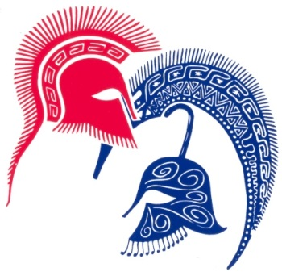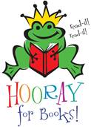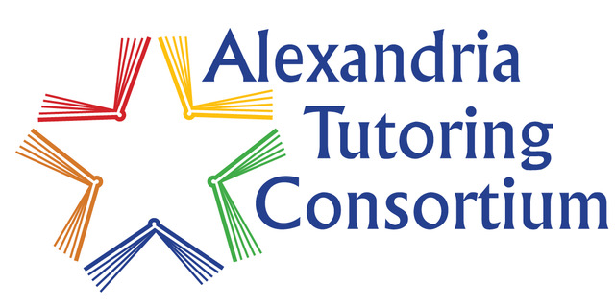

Save the date!

Enjoy holiday music and fun with T.C. Williams students
and volunteers from the Alexandria Tutoring Consortium.

Students from the National English Honor Society will be
on hand to provide gift wrapping.

A portion of your purchases will benefit the T.C. Williams
English Department and the Alexandria Tutoring Consortium.

