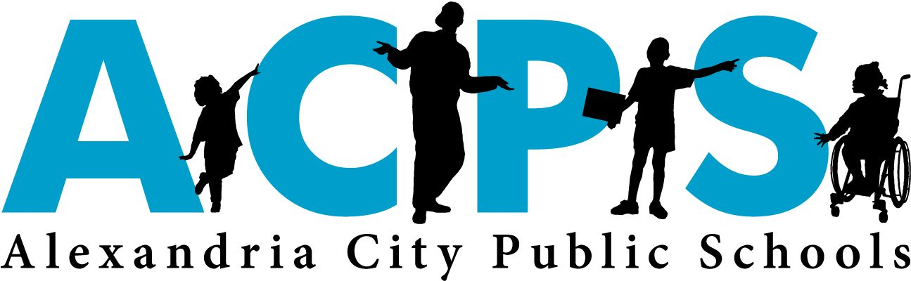

**National Board Certification for Teachers**

**Information Session**

**April 24 @4pm Central Office (310-3A) April 25 @4pm TCWHS**

1. **What is National Board Certification**?

* The founding mission of the National Board for Professional Teaching Standards is to advance the quality of teaching and learning by:
* Maintaining high and rigorous standards for what accomplished teachers should know and be able to do;

* Providing a national voluntary system certifying teachers who meet these standards;

* Advocating related education reforms to integrate National Board Certification in American education and to capitalize on the expertise of National Board Certified Teachers

1. **What does the National Board Certification process entail?**

http://www.nbpts.org/national-board-certification

1. **Am I eligible?**

http://boardcertifiedteachers.org/certificate-areas

1. **What are the fees and what ACPS support is available to candidates? What are the extrinsic incentives?**

BEFORE: Register as an applicant for the Annual Registration Fee $75

For ACPS cohort fill out application on ACPS Google Forms: <https://goo.gl/forms/710HJUQnPoHMdA5j1>

DURING: ACPS Candidate Support Course (sign up in PLMS) To Be Decided

AFTER: State Stipend: $5000 (Year 1) $2500 (Year 2-10) ACPS Bonus: $2200 (Year 1-10)

Recertification Points: Range from 45-180

1. **Next Steps:**

|  |  |
| --- | --- |
| If…. | Then…. |
| I am interested in pursuing NBCT | Visit http://www.nbpts.org/national-board-standard |
| I am applying for ACPS funding | See above. All applications are due by May 18, 2018 |
| I am going to pay for this on my own | Complete registration process. |

**Contacts:**

Melissa King – Renewal Candidates and Cohort (Years 2 & 3) ([Melissa.king@acps.k12.va.us](mailto:Melissa.king@acps.k12.va.us))

Michelle Hudgens – Cohort (Year 1) ([Michelle.Hudgens@acps.k12.va.us](mailto:Michelle.Hudgens@acps.k12.va.us))

Debra Lane – Director of Talent Development ([Debra.lane@acps.k12.va.us](mailto:Debra.lane@acps.k12.va.us))

**Questions:** NBCT Customer Support: Monday through Friday, from 8:00 a.m. to 6:00 p.m. CDT, 1-800-22TEACH.