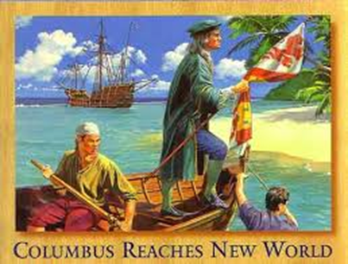
Explorers Poetry Book

Name_______
May-June 2015

Explorers Here, Explorers There
Written by Anna Harvin, and Athelia Graham, 2015

Explorers here, explorers there
Explorers, explorers everywhere!

European explorers sailing boldly
Motivated explorers discovering fearlessly
Successful explorers conquering proudly
Curious explorers trading cautiously

Explorers from Europe,
Explorers across the Atlantic Ocean,
Explorers in North America,
Explorers throughout the New World.

Explorers here, explorers there
Explorers, explorers everywhere!
Explorers! Explorers! Explorers!
Oh Columbus!
(Sung to the tune of “Oh My Darling”)

Oh Columbus, Oh Columbus
Landed in San Salvador
He thought he found a western
Sea route to Asia’s Door.

Oh Columbus, Oh Columbus
Sailed from the country Spain
Discovering the New World
Was a blessing not a pain.

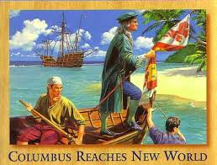
Columbus Day Song 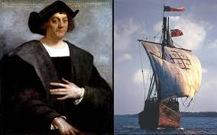
(sung to the tune of "The Farmer in the Dell")
In 1492,
In 1492,
Columbus sailed across the sea,
In 1492.
For 70 days he sailed,
For 70 days he sailed,
Columbus sailed across the sea,
For 70 days he sailed.
He came to a new land,
He came to a new land,
Columbus sailed across the sea,
And came to a new land.
Exploring he did go,
Exploring he did go,
Columbus sailed across the sea,
Exploring he did go.
He sailed back home to Spain,
He sailed back home to Spain,
Columbus sailed across the sea,
Then sailed back home to Spain.
Juan Ponce de Leon 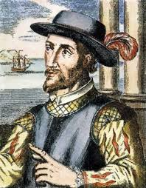
(Sung to the tune of “Oh My Darling”)
Ponce de Leon, Ponce de Leon
Explorer from Spain
He said with Christopher Columbus
Then he sailed back home again.

Fought he Indians, fought the Indians
Then he went to look for gold.
Founded Puerto Rico; was the governor
That’s where he did grow old.

Conquered land, conquered land
He was acting like a sleuth
Claimed land for the country Spain
Searched for the Fountain of Youth

Sailed to Florida, sailed to Florida
Looking for new land,
For Spain, St. Augustine
For King Ferdinand
Cartier
(Sung to the tune of “Are You Sleeping”)

Cartier, Cartier
Came from France, came from France
Wanted to make colonies
In Canada, in Canada

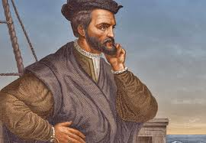

Christopher Newport
(Sung to the tune of “Twinkle, Twinkle Little Star”)

Newport, Newport landed in Jamestown
Made four more voyages to where he had found

Went to the fall line of the James River
Sailed from England for riches to discover

Newport, Newport wanted to find
A way to Asia in a shortened time

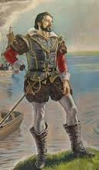

Leif Eriksson Bugaloo
by Anna Harvin 2016

I’m a Viking explorer and here to say,
I love to explore the world every day.
Sometimes I look for passages; sometimes I look for gold.
But most of all I love to be adventurous and bold!

Expeditions, voyages, discoveries, too,
Doing the Exploration Bugaloo!

They call me “Leif the Lucky”, yes it’s true
I sailed the icy North Atlantic, too.
Me and my men were traders from Norway
And you best believe we did things my way.

Expeditions, voyages, discoveries, too,
Doing the Exploration Bugaloo!

I set up settlements in Greenland
Such a cold and frigid island
We were the first to set foot on North American soil
On that wooded land we did toil.

Expeditions, voyages, discoveries, too,
Doing the Exploration Bugaloo!

Me and my men tried to set up camp where we’d been.
But there were just too many American Indians
Ruins of cabins found later do proclaim
Vikings were in Canada, so don’t forget my name!

Expeditions, voyages, discoveries, too,
Doing the Exploration Bugaloo!

