1.Name the 3 structures protozoans have for locomotion:
(flagellum) (pseudopod) (cilia)

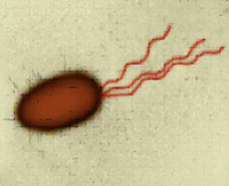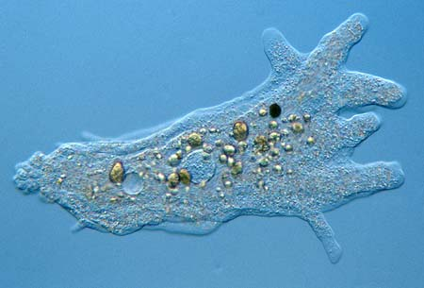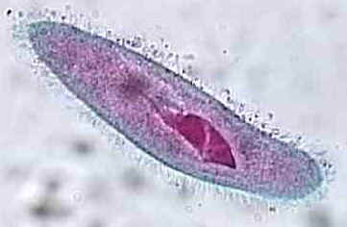

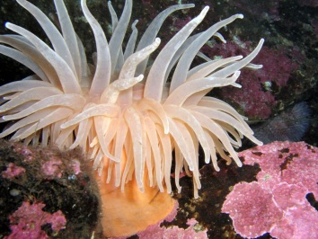
2. Which of these organisms contains no specialized cells?
a. Paramecium
b. Sponge
c. Jellyfish
d. Sea anemone

3. Protists live in aquatic environments. Water enters their cells by osmosis. What structure keeps them from bursting/exploding?

Protists have a contractile vacuole that keeps them from bursting.

4. Why are protists the “weirdos” of classification? Why are they hard to define?
Protists have various traits. Some are plant-like or fungus-like or animal-like. Some are motile but others are sessile. They are hard to classify.

