STATION ACTIVITY: Dichotomous Keys
Station 1: Name ____________________________

1. Look at Sample #1. Go through the dichotomous key to find out the answers to these questions.

Scientific name: __________________________________

Common name: _________________________________

2. Look at Sample #2. Go through the dichotomous key to find out the answers to these questions.

Genus: __________________________________

species: _________________________________

Station 2:

1. Look at Sample #3. Go through the dichotomous key to find out the answers to these questions.

Common name: __________________________________

Genus: _________________________________

2. Look at Sample #4. Go through the dichotomous key to find out the answers to these questions.

Genus: __________________________________

species: _________________________________

Station 3:

1. Look at Sample #5. Go through the dichotomous key to find out the answers to these questions.

Genus: __________________________________

Common name: _________________________________

2. Look at Sample #6. Go through the dichotomous key to find out the answers to these questions.

Scientific name: __________________________________

species: _________________________________

Station 4:

1. Look at Sample #7. Go through the dichotomous key to find out the answers to these questions.

Scientific name: __________________________________

Common name: _________________________________

2. Look at Sample #8. Go through the dichotomous key to find out the answers to these questions.

species: __________________________________

Genus: _________________________________

Station 5: Help! Scientists have discovered new aliens on Planet Gordonia. They need your help to identify them. Use the dichotomous key on your table.
WRITE THE ALIEN’S NAME BELOW EACH PICTURE. Capitalize the genus, do not capitalize the species. Underline both! Example: Homo sapiens
1. 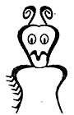 | 2. | 3. 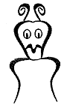
_________________ __________________ ___________________

* = star = antennae = arch

symmetrical = same on both sides

hairy spikes =

Finished your station early? Try these real SOL ?s:
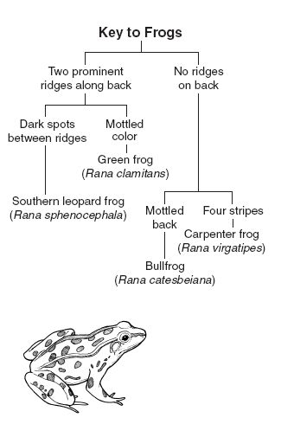
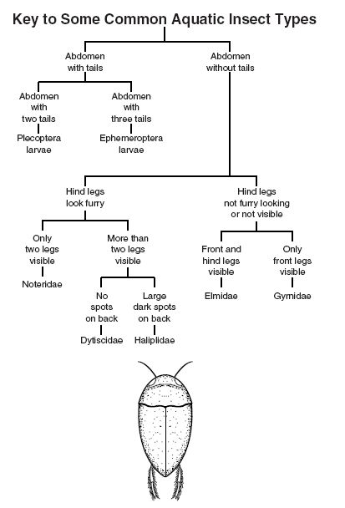
1. According to the key above, to what family 2. The above key can be used to does the insect above belong? distinguish
species of frogs found in ponds in eastern Virginia. To which species does the frog shown belong?
a. Dytiscidae
b. Haliplidae a. Rana sphenocephala
c. Gyrnidae b. Rana clamitans
d. Noteridae c. Rana catesbeiana
d. Rana virgatipes

3. | Look at the dichotomous key given below.  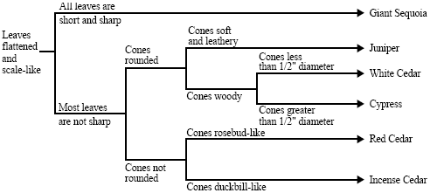  A tree with scale-like leaves and rounded, woody cones greater than 1/2" in diameter would be identified as which of the following?
 | a. | Giant Sequoia b. Cypress c. Juniper d. Red Cedar
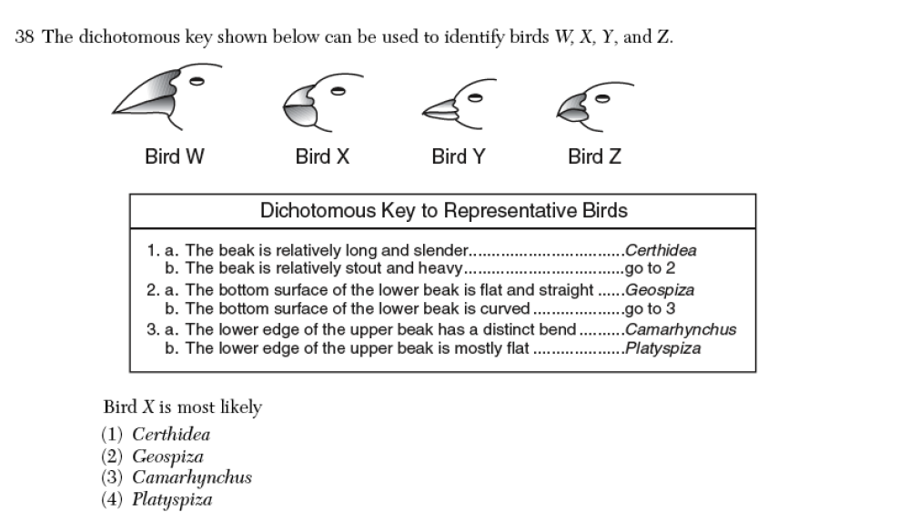

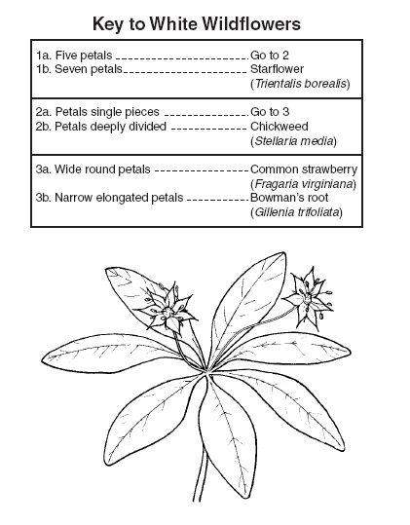

This dichotomous key can be used to distinguish white wildflowers found in Virginia. According to this key, what type of flower is shown?

a. Trientalis borealis
b. Stellaria media
c. Fragaria virginiana
d. Gillenia trifoliata

