Musical  - Writing their own songs and music about content-area topics.  - Putting original poems to music, and then performing them for the class.  - Incorporating a poem they have written with a melody they already know.  - Listening to music from different historical periods.  - Tape recording a poem over "appropriate" background music (i.e., soft music if describing a kitten, loud music if they are mad about pollution).  - Using rhythm and clapping to memorize math facts and other content-area information. | Bodily Kinesthetic  - Creating costumes for role-playing, skits, or simulations.  - Performing skits or acting out scenes from books or key historical events.  - Designing props for plays and skits.  - Using charades to act out characters in a book, vocabulary words, animals, or other content-area topics.  - Participating in scavenger hunts, searching for items related to a theme or unit.  - Acting out concepts. For example, for the solar system, "student planets" circle around a "student sun." Students line up appropriately to demonstrate events in a history timeline. | Interpersonal  - Working in cooperative groups to design and complete projects.  - Working in pairs to learn math facts.  - Interviewing people with knowledge about content-area topics (such as a veteran to learn about World War II, a lab technician to learn about life science, or a politician to understand the election process).  - Tutoring younger students or classmates.  - Using puppets to put on a puppet show.
Verbal-Linguistic  - Completing crossword puzzles with vocabulary words.  - Writing short stories for a classroom newsletter.  - Writing feature articles for the school newspaper.  - Writing a letter to the editor in response to articles.  - Writing to state representatives about local issues.  - Using digital resources such as electronic libraries, desktop publishing, word games, and word processing.  - Telling a story to the class.  - Participating in debates. | 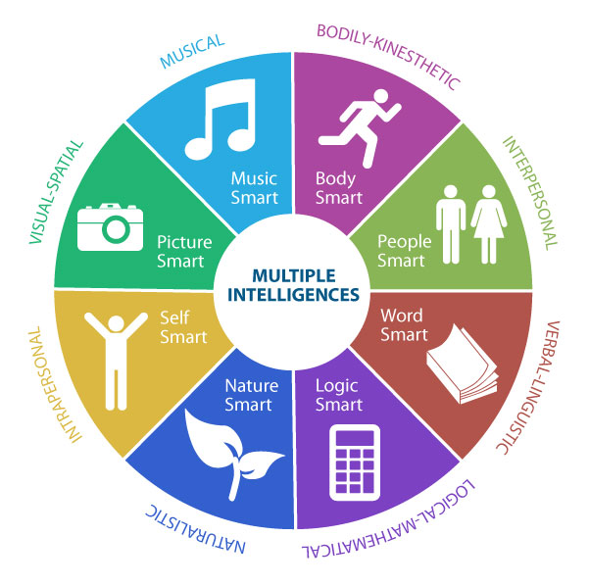  Multiple Intelligence Menu | Logical Mathematical  - Searching for patterns  - Conducting experiments to demonstrate science concepts.  - Using math and science software such as Math Blaster, which reinforces math skills, or King's Rule, a logic game.  - Using science tool kits for science programs.  - Designing alphabetic and numeric codes.  - Making up analogies.
Naturalistic  - Caring for classroom plants.  - Caring for classroom pets.  - Sorting and classifying natural objects, such as leaves and rocks.  - Researching animal habitats.  - Observing natural surroundings.  - Organizing or participating in park/playground clean-ups, recycling drives, and beautification projects. | Intrapersonal  - Writing reflective papers on content-area topics.  - Writing essays from the perspective of historical figures, such as Civil War soldiers or suffragettes.  - Writing a literary autobiography, reflecting on their reading life.  - Writing goals for the future and planning ways to achieve them.  - Using software that allows them to work alone  - Keeping journals or logs throughout the year.  - Making a scrapbook for their poems, papers, and reflections. | Visual Spatial  - Using clay or play dough to make objects or represent concepts from content-area lessons.  - Using pictorial models such as flow charts, visual maps, Venn diagrams, and timelines to connect new material to known information.  - Taking notes using concept mapping, mind mapping, and clustering.  - Using maps to study geographical locations.  - Illustrating poems for the class poetry book by drawing or using computer software.

