Musical | Bodily Kinesthetic | Interpersonal
Verbal-Linguistic | 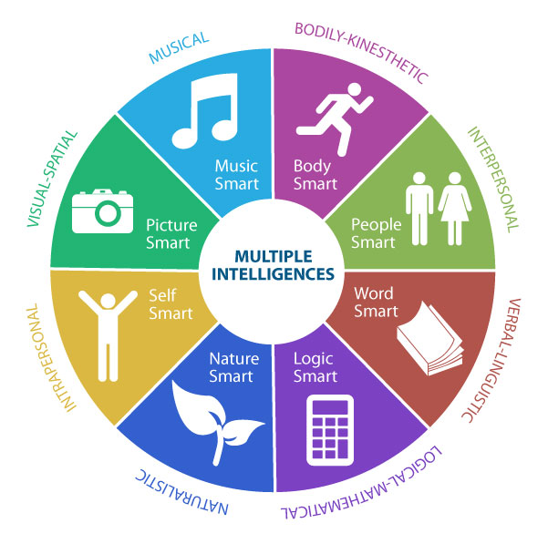  Multiple Intelligence Menu | Logical Mathematical
Naturalistic | Intrapersonal | Visual Spatial

