PRE-READING
Directions: Look at the poster. Make a prediction about the Marshall Plan. (ex: What was it? When was it created? Where was it implemented? Why was it necessary?)
_________________________________________________________________________________________________________________________________________________________________________________________________________________________________________________________________________________________________________________________________________________

PRE-READING
Directions: Look at the poster. Make a prediction about the Marshall Plan. (ex: What was it? When was it created? Where was it implemented? Why was it necessary?)
_________________________________________________________________________________________________________________________________________________________________________________________________________________________________________________________________________________________________________________________________________________

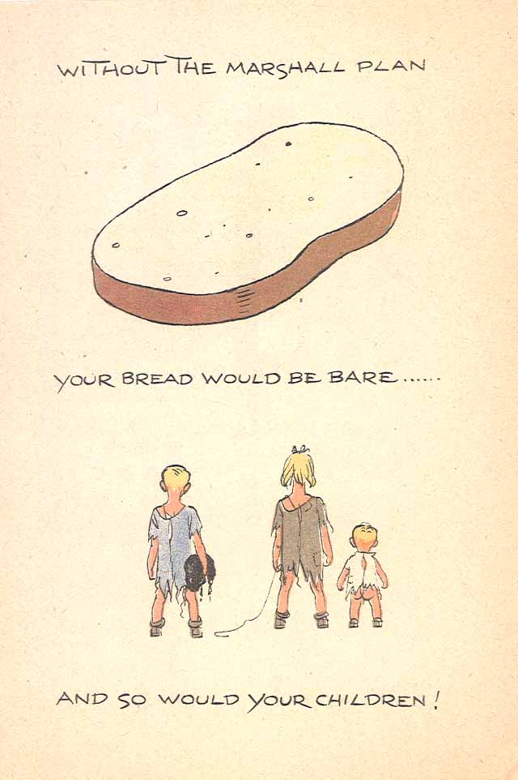
Jo Spier. The Marshall Plan and You. The Hague, the Netherlands: Ministry of Economic Affairs, 1949. Library of Congress.

Jo Spier. The Marshall Plan and You. The Hague, the Netherlands: Ministry of Economic Affairs, 1949. Library of Congress.

POST-READING
Directions: Look at the poster. Reflect on the reading. Describe the Marshall Plan and how it relates to the essential question, “What responsibilities do we have to others in the world?”
_________________________________________________________________________________________________________________________________________________________________________________________________________________________________________________________________________________________________________________________________________________

POST-READING
Directions: Look at the poster. Reflect on the reading. Describe the Marshall Plan and how it relates to the essential question, “What responsibilities do we have to others in the world?”
_________________________________________________________________________________________________________________________________________________________________________________________________________________________________________________________________________________________________________________________________________________

